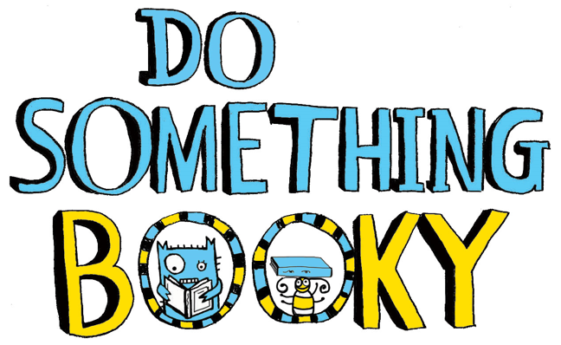
Weekly Book Bulletin!
This week, our update for you is
all things POETRY! Enjoy the
selection we have put together for
you and happy home learning. w/c 27.4.20
Last week, a pupil from Holsworthy Primary said “I don’t think I like poetry...” My response? “That just means you’re reading the wrong poetry!”
Poetry is everything: wonderfully funny, moving, intense, artistic, silly... whatever you want it to be; there is poetry for everyone.

So to tickle your taste buds, PLEASE start by watching the incredibly funny Michael Rosen reading his famous poem, ‘Chocolate Cake’. Make sure your parents watch it too – this poem will brighten up anyone’s day! You can find it here https://www.michaelrosen.co.uk/poems-and-stories-about-my-family/ or on YouTube where he has hundreds or poems to peruse.

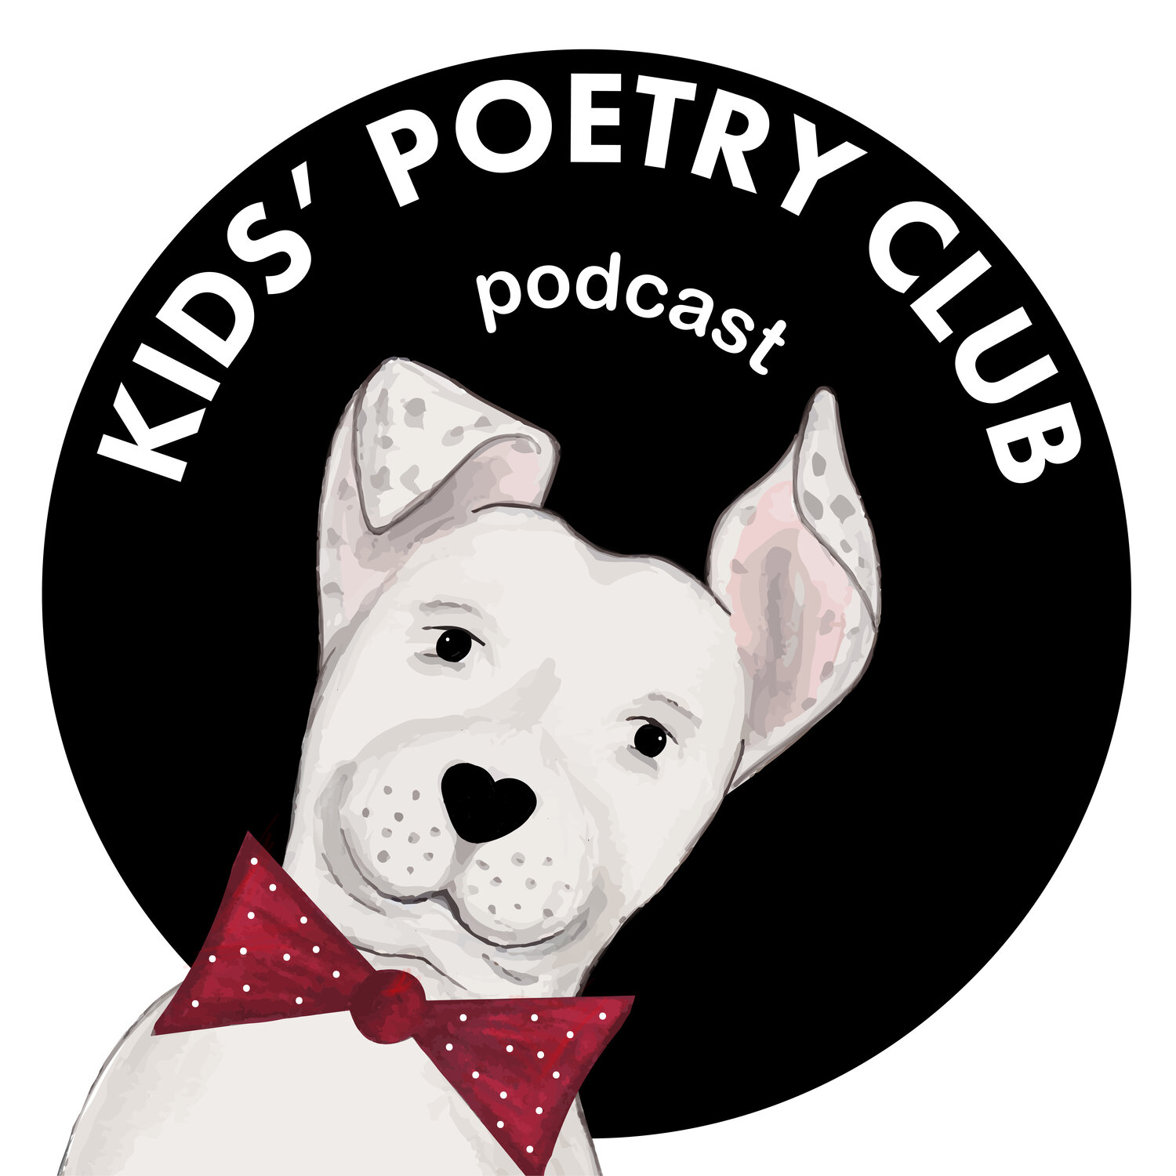
In terms of finding poetry reading content, some useful websites are kidspoetryclub.com and poetryfoundation.org. Both these sites offer audio poetry and written poetry covering a huge range of genres. Kids Poetry Club also has a wide range of free podcasts to listen to – all based upon brilliant poems.
Look out for next week’s update on non-fiction... happy reading!

