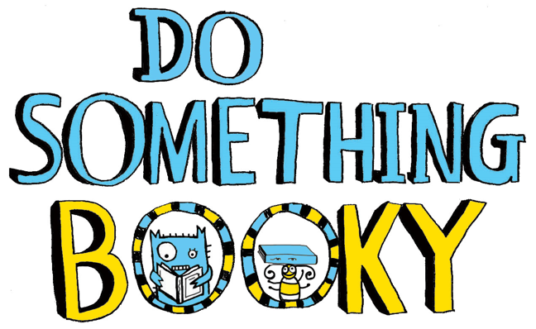
Weekly Book Bulletin!
This week, our update is focussed
on the brilliant world of non-fiction!
Two jam-packed pages this time as
we had so much to share with you. w/c 04.05.20

First up (before we delve into non-fiction) we’d like to introduce you to a little bit of booky fun. Hit https://www.penguin.co.uk/articles/children.html to access a range of free quizzes, games and podcasts based on some texts you love from school. Not to mention some fabulous audio books. This website is well-worth a look as children are likely to be able to access the resources independently; buying you parents a few minutes of precious time!

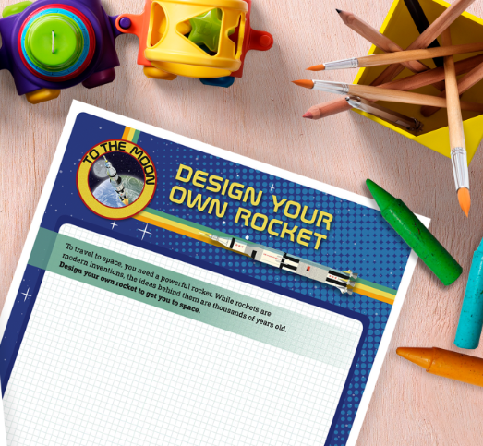
One FANTASTIC website you will love is DK.com. Simply go to the ’Stay Home Hub’ to find a vast range of resources available from pre-school age upwards. They have covered most curriculum areas with a non-fiction text (or extract) and adjoining learning activities. We hope you have fun exploring this great online resource.

If you’re interested in reading whole non-fiction texts, we highly recommend another visit to ‘myON’ https://readon.myon.co.uk/library/browse.html. This web address will take you directly to the page where you can select from over 7,000 categorised ebooks. 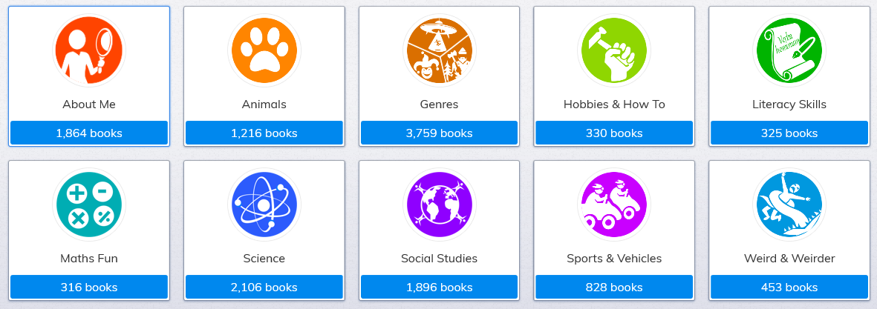

A little something for parents... if you’re seeking guidance on the specifics of non-fiction texts types, visit The School Run here https://www.theschoolrun.com/non-fiction. This website has heaps of guidance on many things but we thought this link in particular might be useful to you.

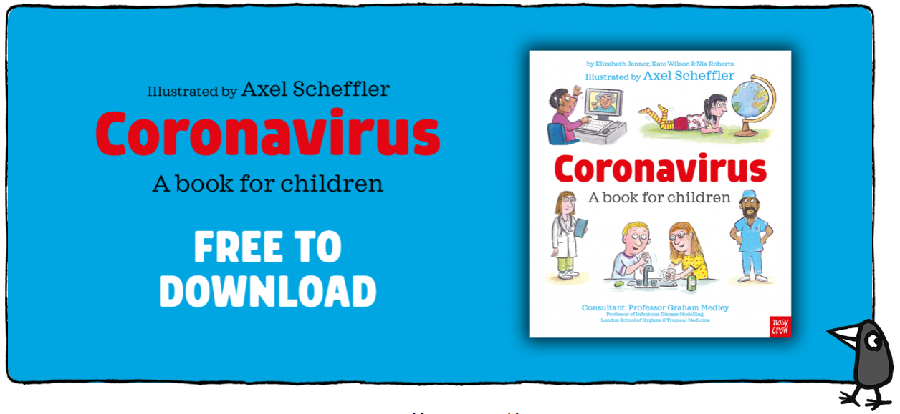Finally, we’d like to draw your attention to NosyCrow.com where we highly recommend this free coronavirus book which is specifically aimed at children. The illustrator Axel Scheffler (famous for illustrating The Gruffalo etc.) has teamed up with actor Hugh Bonneville for Nosy Crow to create a video, audio-book and PDF version of this invaluable resource.
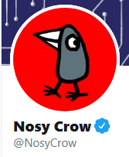
Finally finally... if you are a social media fiend, simply use the twitter handle #nosycrowdiscover where they post superb non-fiction extracts that are not only relevant and on-trend, but brilliant reads.

Look out for next week’s update on fiction... happy reading!